Bài 9:

1. 0x01304024

* And $t0,$t1,$s0

1. 0x2128fff3

* Addi $t0,$t1,-14

1. 0xad28fffc

* Sw $t0,-4($t1)

Bài 10:

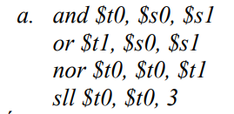

$t0=0x00000000

$t1=0x1234567F

$t0=0xEDCBA980

* $t0=6E5D4C00
* $t1=0x1234567F
* $S0=0x12345678
* $S1=0x00000007

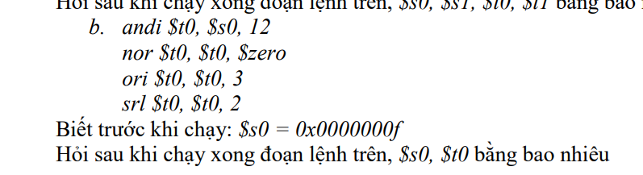

$t0=0x0000000C

$t0=0xfffffff3

$t0=0xfffffff3

$t0=0x3ffffffC

* $t0=0x3ffffffC
* $s0=0x0000000f

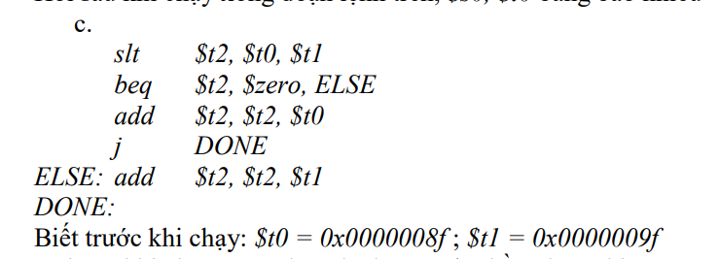

$t2=1

$t2=0x00000090

* $t2=0x00000090

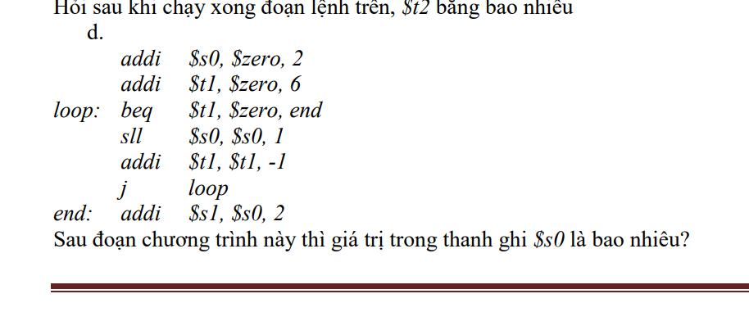

$s0=2

$t1=6

$s0=4

$t1=5

$s0=8

$t1=4

$s0=16

$t1=3

$s0=32

$t1=2

$s0=64

$t1=1

$s0=128

$t1=0

$s1=130

* $s0=128